KJ2031 kompendium – Ninni
Bond theories
 | Description | Advantages | Disadvantages
Lewis | ▪ Covalent bonding  ▪ Octet rule  ▪ 2D structure | ▪ Bond orders  ▪ Lone pair  ▪ Formal charge  ▪ Bonding energy  ▪ Resonance | ▪ Molecular geometry (shape)  ▪ Bond angles
VSEPR | ▪ Electron density determines shape  ▪ Bonding & lone-pair regions | ▪ 3D shape  ▪ Some info on bond angles  ▪ Best for spatial arrangement | ▪ Difficult to predict if >1 similar energy structure  ▪ Cannot predict  actual bond angle
VB | ▪ Quantum mechanics  ▪ Considers orbital interaction  ▪ AO overlap bonding  ▪ Hybridization | ▪ 3D structure  ▪ Bond angle info  ▪ Considers repulsion between electron density regions | ▪ Does not easily handle polyatomic molecules  ▪ Localized hybrid orbitals
MO | ▪ #MOs = #AOs  ▪ Probability to find in internuclear region by wavefunction for each e⁻  ▪ Constructive and destructive AO interference bonding and antibonding MO’s  ▪ AOs must have the same symmetry to form MOs  ▪Aufbau, Pauli, Hund  ▪ σ, π and δ-orbitals | ▪ Good for predicting electronic spectra and paramagnetism  ▪ Good for diatomic molecules | ▪ Delocalized electrons no resonance structures  ▪ Complex for polyatomic

Aufbau | Pauli exclusion principle | Hund’s rule
Electrons fill atomic orbitals of lowest available energy levels before occupying higher levels. | No two electrons in the same atom can have all 4 identical quantum numbers. Max two electrons per orbital which must have opposite spin. | - Bus seat principle.  Orbitals of equal energy are each occupied by one electron (of same spin) before any orbital is occupied by a second electron.

σ-orbitals | π-orbitals | δ-orbitals
▪ Overlapping of 2 AOs having cylindrical  symmetry around internuclear axis  ▪ 2s & 2p_{z} | ▪ Remaining 2p orbitals having nodal plane on z-axis  ▪ 2p_{y} & 2p_{x}  ▪ Doubly degenerate pair of bonding and antibonding MOs | ▪ $d_{x^{2}-y^{2}}$ and d_{xy} hav no counterparts like s and p  ▪ Match with other atoms  ▪ Doubly degenerate pairs of B and AB 𝛿 orbitals

Point groups with operations |  | Example
D_{∞h} | Linear + i | 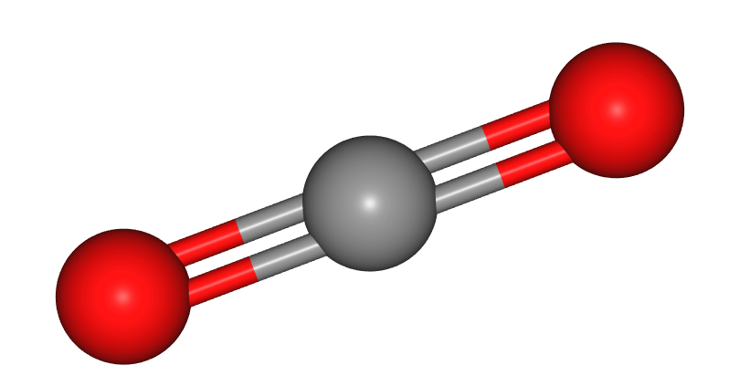 CO₂
C_{∞v} | Linear | 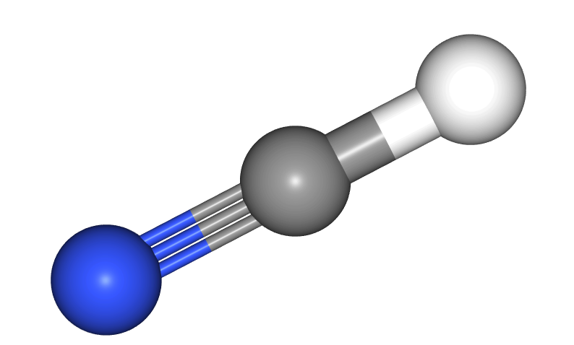 hydrogen cyanide
I_{h} | $≥$C₃ + i + C₅ | 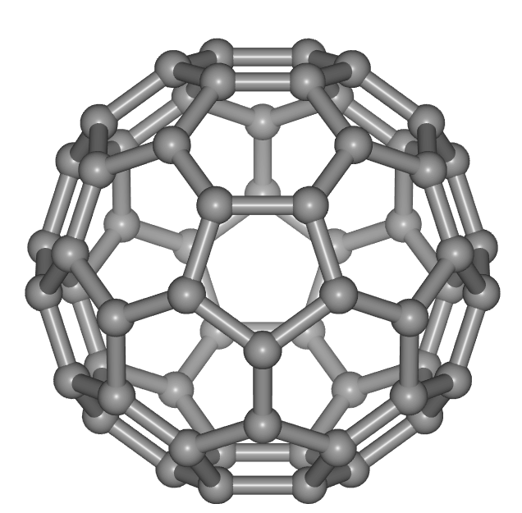 buckyball
O_{h} | $≥$C₃ + i + cubic | 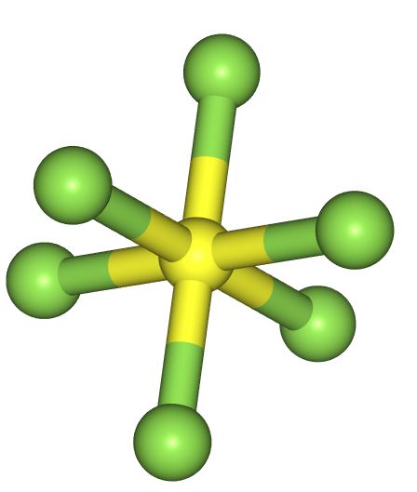 SF₆
T_{d} | $≥$C₃ + cubic | 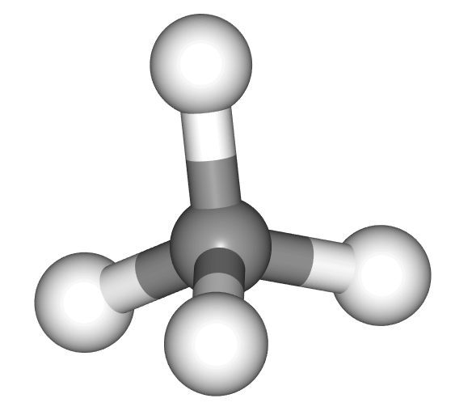 methane
D_{nh} | C_{n} + σ_{h} + nC₂ $⊥$ C_{n} | 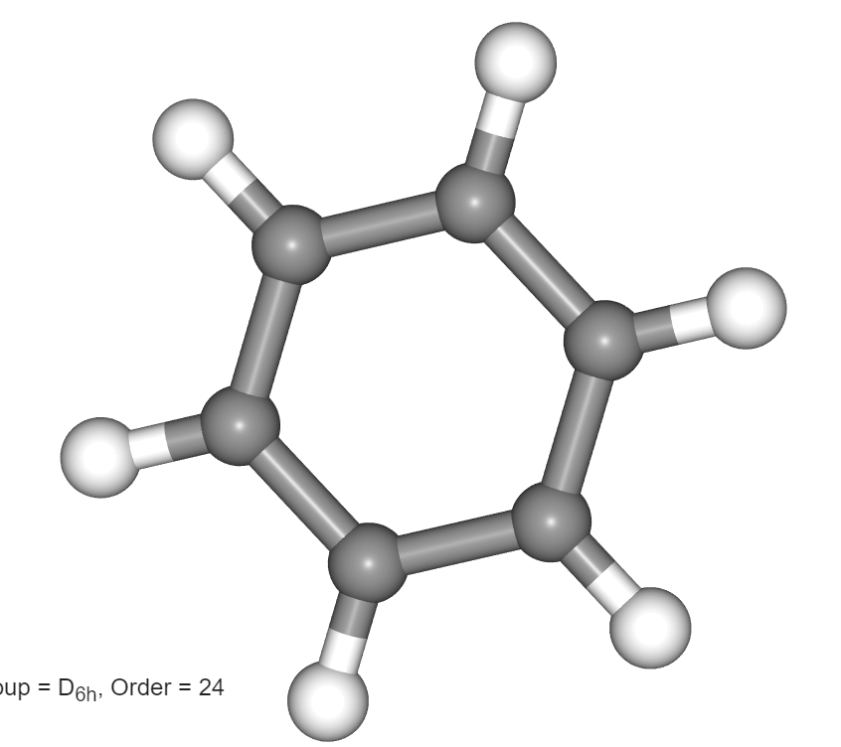 D_{6h}: benzene
D_{nd} | C_{n} + nσ_{d} + nC₂ $⊥$ C_{n} | 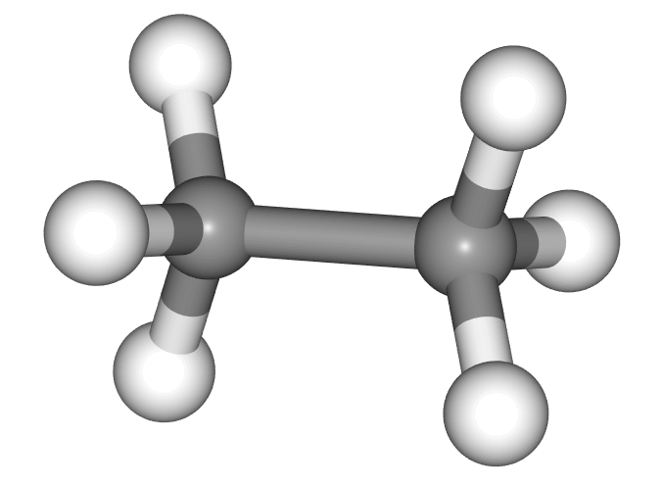 D_{3d}: staggered ethane
D_{n} | C_{n} + nC₂ $⊥$ C_{n} | 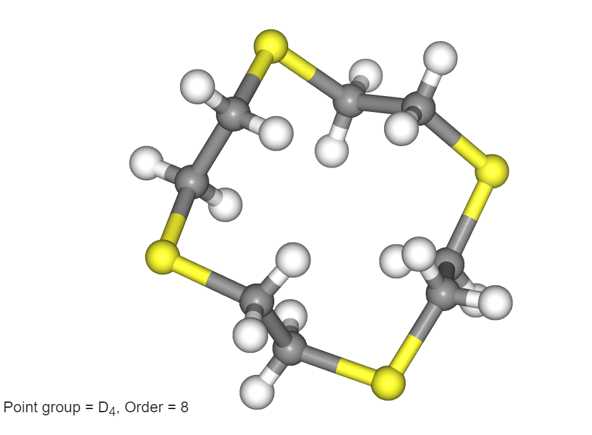 D₄: tetrathiacyclododecane
C_{nh} | C_{n} + σ_{h} | 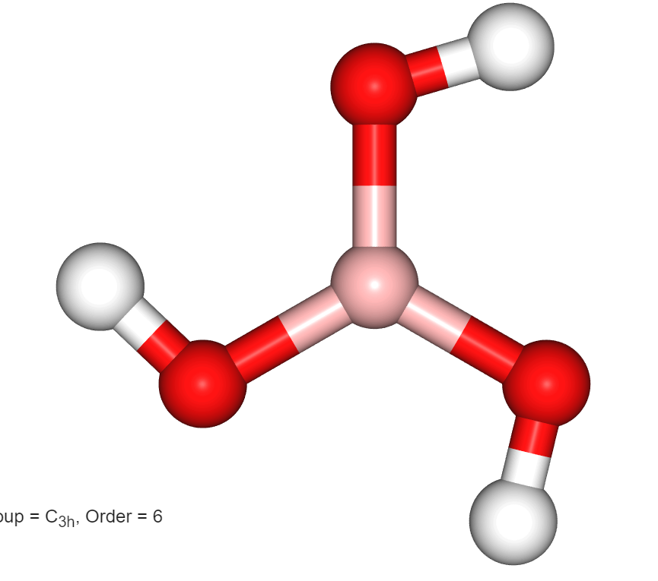 C_{3h} : boric acid
C_{nv} | C_{n} + nσ_{v} | 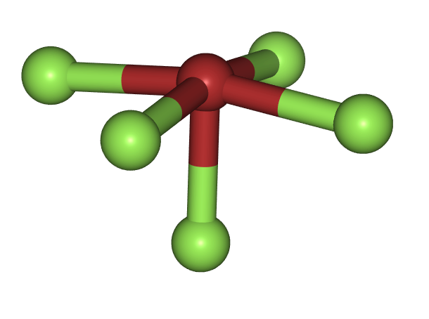 C_{4v}: BrF₅ & C_{3v}: NH₃ & C_{2v}: H₂O
C_{n} | C_{n} | 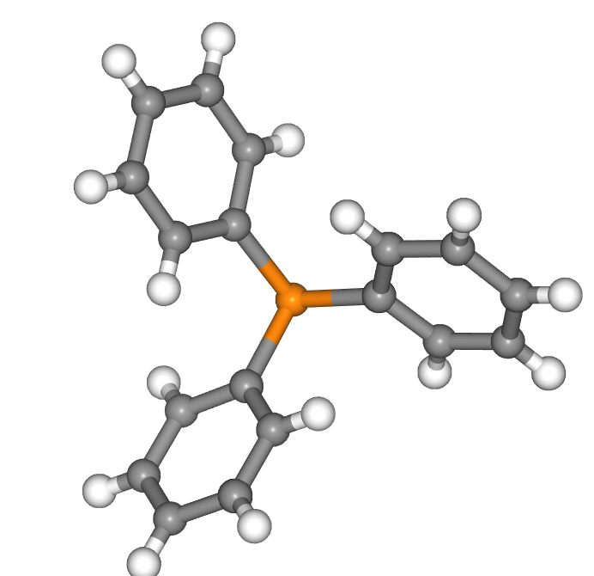 C₃: triphenylphosphine
S_{2n} | C_{n} + S_{2n} | 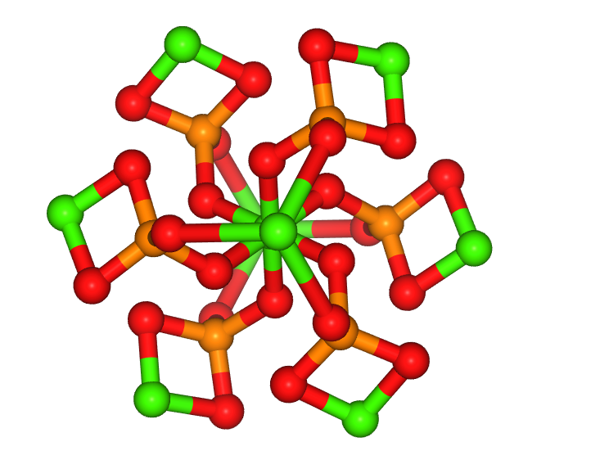S₆: posner molecule
C_{s} | σ_{h} | 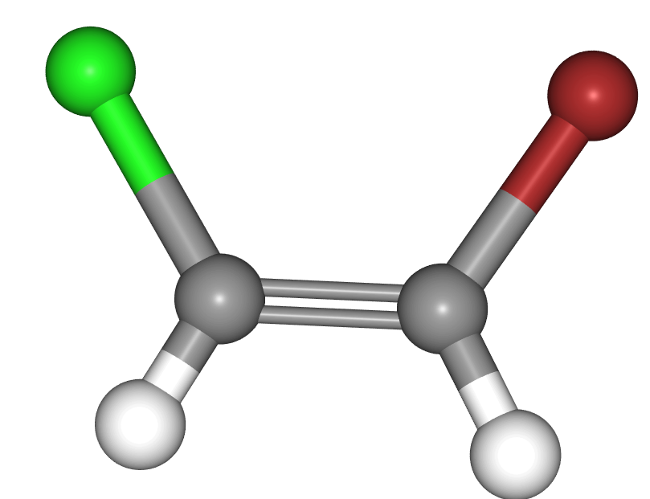 ethylene-BrCl
C_{i} | i | 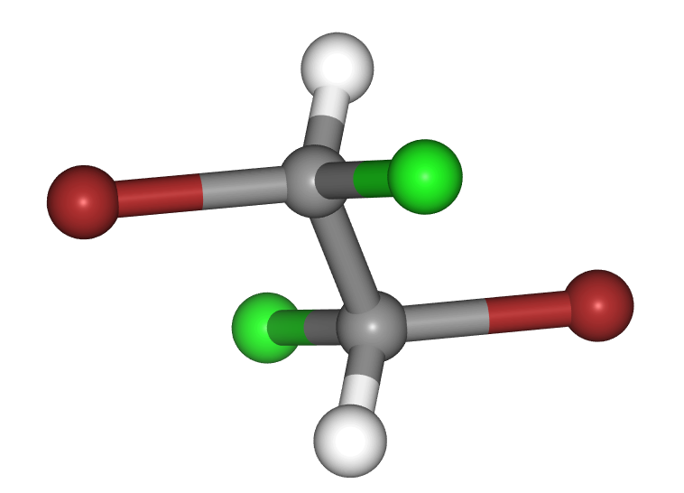 ethane-Br₂Cl₂
C₁ | E | 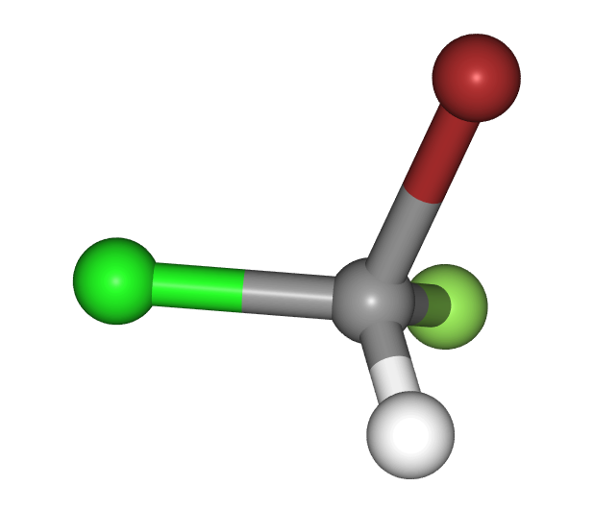 bromochlorofluoromethane
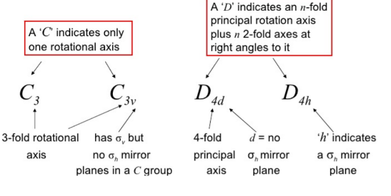
It has σ_{d} if it bisects two C₂
Symmetry operations
E | Identity
C_{n} | Rotation axis
σ | Mirror plane: h,v,d
i | Inversion center
S_{n} | Rotation + reflection

Group orbitals and SALC’s
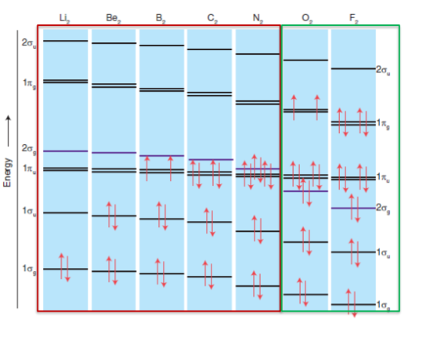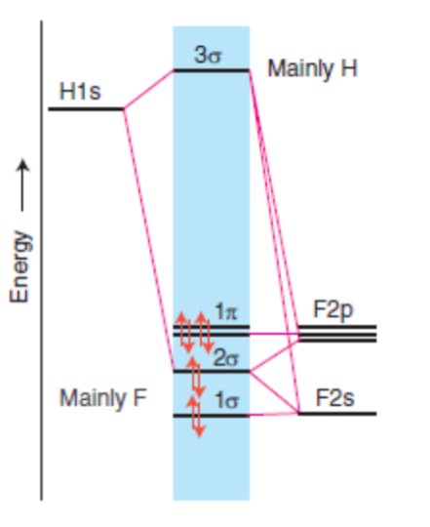
N₂ & O₂: D_{∞h} HF: C_{∞v}

Character table
Symmetry species / types
- A: function is symmetric with respect to rotation character = 1
- B: function changes sign under rotation character = -1
- A₁: 1 refers to symmetric with respect to reflection in principle vertical plane
- A₂: 2 function changes sign under reflection

Point groups
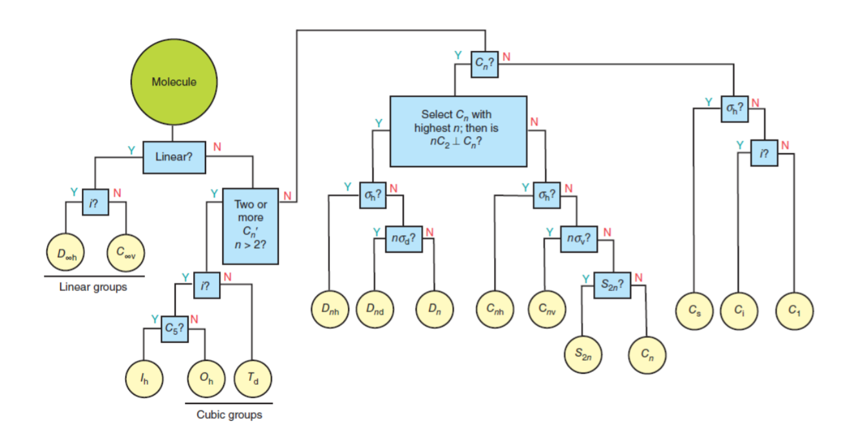
Famous molecules
 | MO | Character table | Spectra
BeH₂  Point gr.:  D_{∞h} | 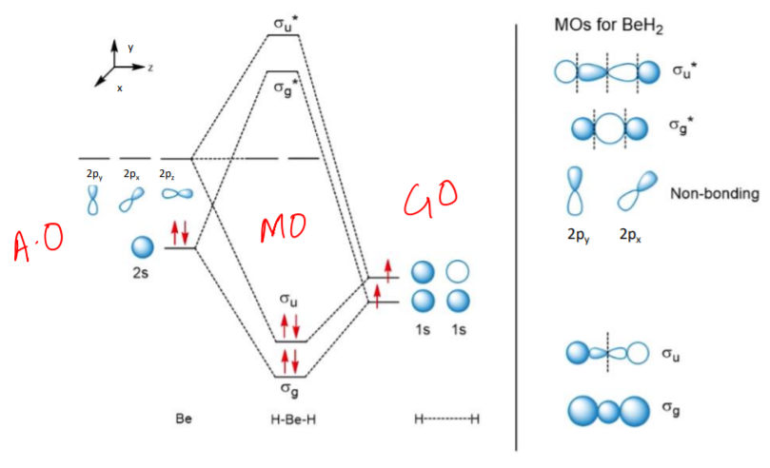 | (linear)  E + C∞, C₂, i, σ_{v}  A_{1g}: 2s + Φ⁺  A_{1u}: 2p_{z} + Φ⁻  E_{1u}: (2p_{x} & 2p_{y}) | 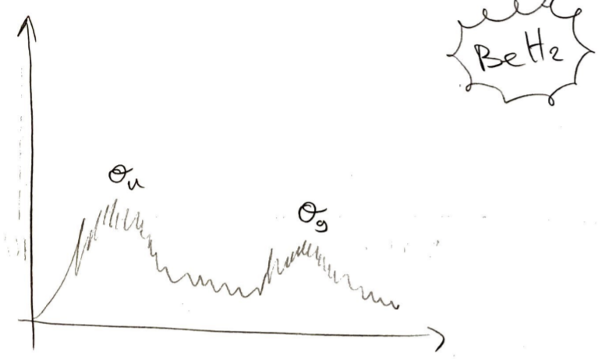
BH₃  Point gr.:  D_{3h} | 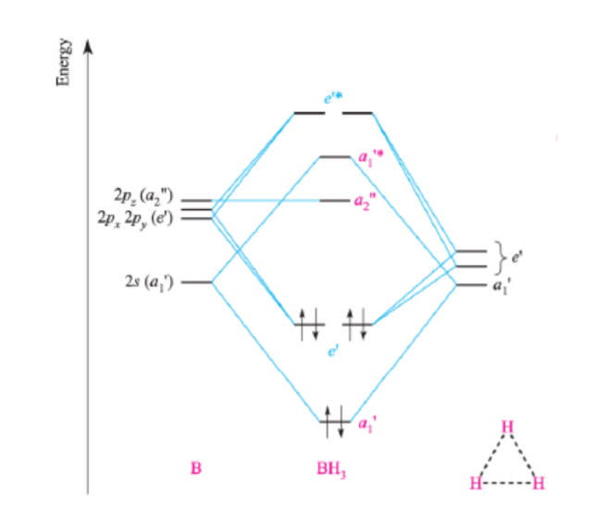 | E, C₃, 3C₂, σ_{h}, 3σ_{v}, 3S₃  A₁’: 2s + Φ₁  A₂’’: 2p_{z}  E’: (2p_{x}&2p_{y}) + Φ₂ + Φ₃ | 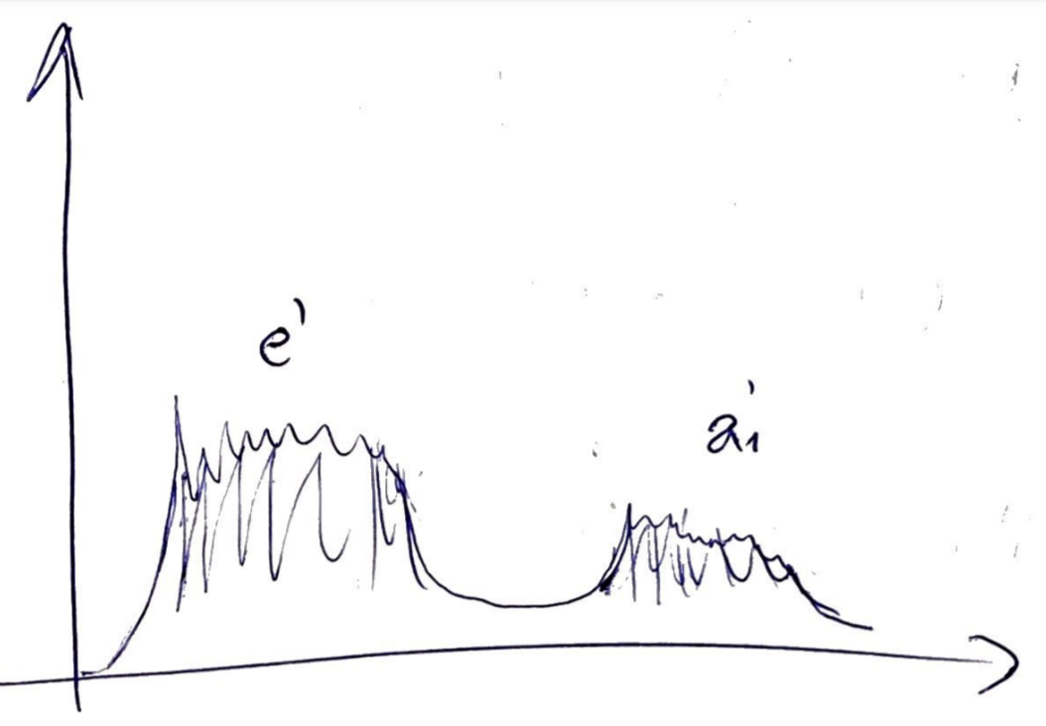
H₂O  Point gr.:  C_{2v} | 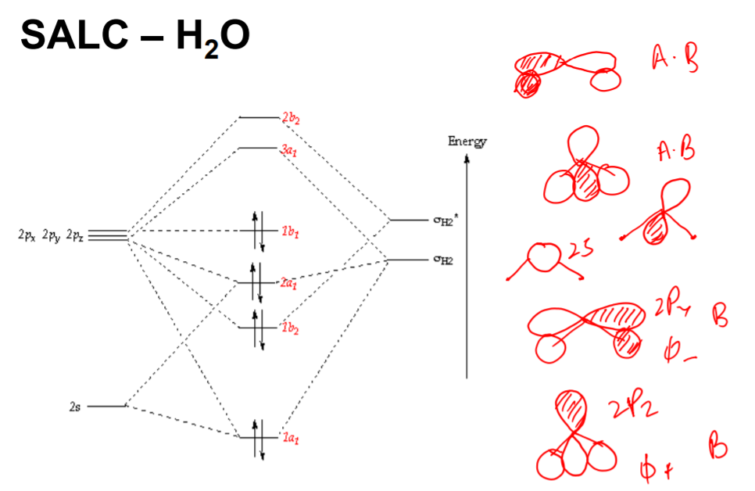 | E, C₂, σ_{v}(xz), σ_{v}(yz)  A₁: 2s, 2p_{z}, Φ⁺  B₁: 2p_{x}  B₂: 2p_{y} + Φ⁻
NH₃  Point gr.:  C_{3v} | 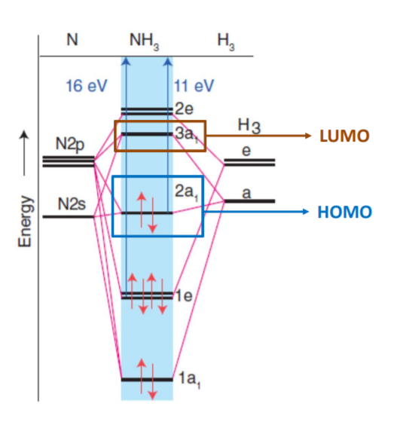 | E, C₃, σ_{v}  A₁: 2s + 2p_{z} + Φ₁  E: (2p_{x}&2p_{y}) + Φ₂ + Φ₃ | 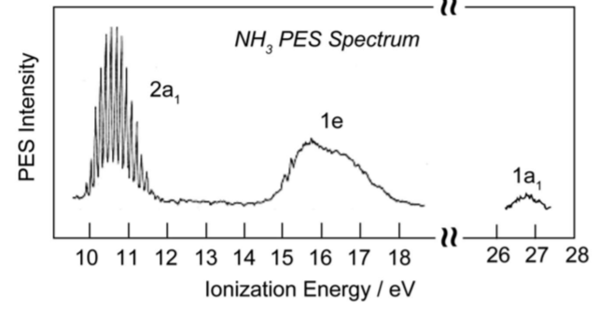
N₂  O₂  Point gr.:  D_{∞h} | 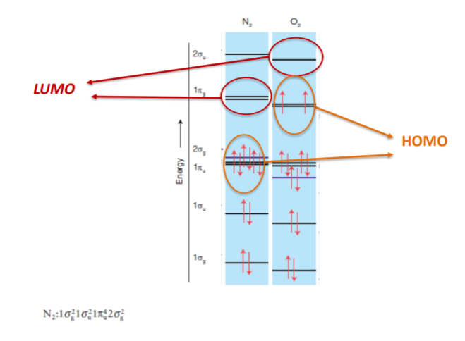 | E, C∞, C₂, i, σ_{v}

Which MO has higher energy?
- Number of nodes
- Amount destructive interference
Walsh diagrams
AH₂  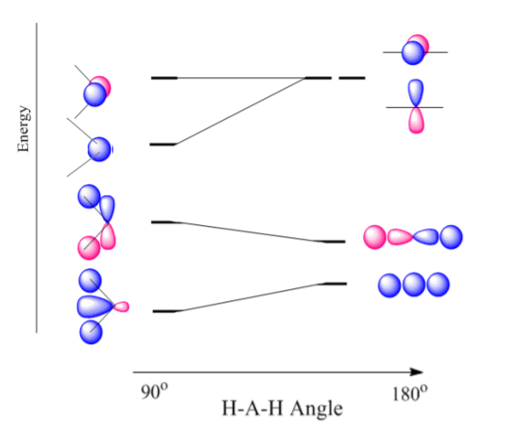  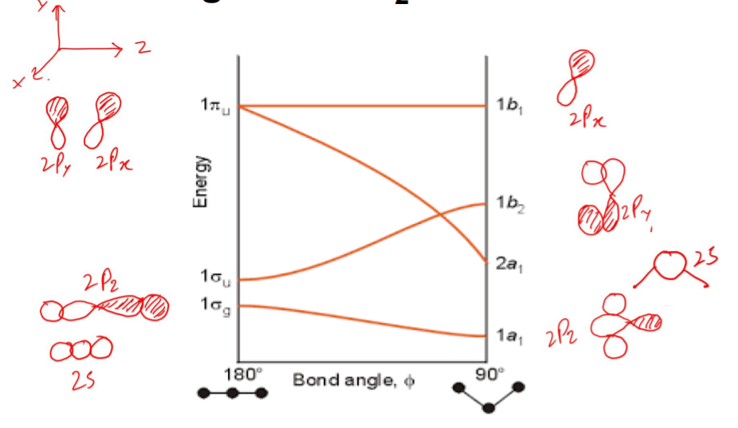 | AH₃  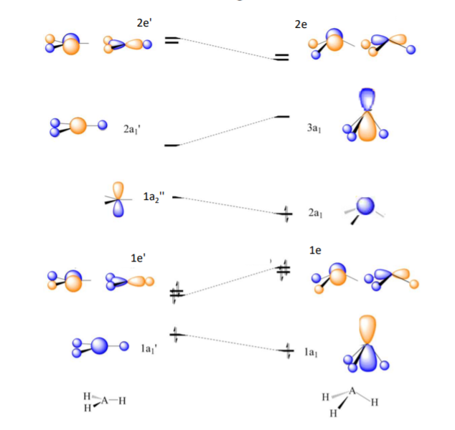  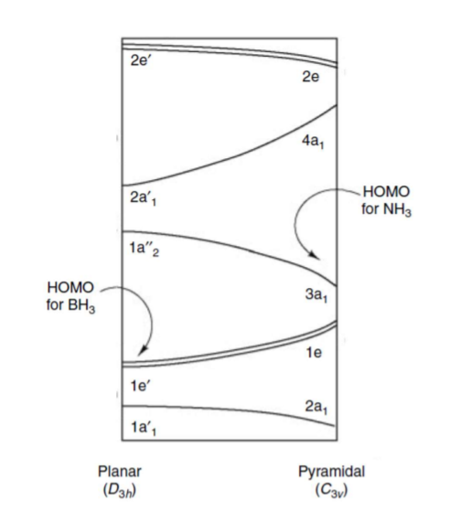
XPS (PES) | UPS (PES) | XAS
▪ Source: often Mg or Al-anode  ▪ bombardment of high energy electron beam radiations ionization from core orbitals of elements in the sample  ▪ Characteristic of elements  ▪ Oxidation states  ▪ Line width of radiation is 1-2 eV  ▪ Not suitable to study the fine detail of valence orbitals  ▪ To study the band structure of orbitals  ▪ For surface elemental analysis of solids  ▪ Due to mean free path of electron in solid being 1 nm | ▪Source: He discharge lamp  ▪ Line width is much smaller than XPS (0.01)  - valence energy levels  - vibrational fine structure  - Bonding or antibonding character of orbitals from which electrons are ejected  ▪ Koopman’s theorem:  - ionization energy is equal to the negative of orbital energy  ▪ The KE of photoelectron can be used to determine orbital energy | ▪ Find local geometry and electronic structure  ▪ EMR from charged particles (e⁻) in a magnetic field  ▪ Intensity from ionization of core-electrons in transition metals  ▪ XANES (near edge)  - Find oxidation state (higher state = higher ionization energy)  - Symmetry (shoulder and pre-edge)  - Fingerprint (compare)  ▪ EXAFS  - #neighbors & type  - Bond length  - # of shells and distance  - Fourier transformation  ▪ Limitations  - Cannot differentiate oxidation states if mix  - Cannot differentiate very similar atoms  - Short-range technique  GOOD: Precise atomic distance and bond length

Fotoelektronspektroskopi (PES) er en teknikk hvor man sender inn monokromatisk elektromagnetisk stråling på en prøve som fører til utsendelse av elektroner. Ved å måle den kinetiske energien til utsendte elektroner kan man finne ioniseringsenergien/bindingsenergien til AO/MO nivået elektronet kom fra ved hjelp av Koopmanns likning: Ek = hv – Ei. Ved innsendelse av røntgen slår man løs kjerneelektroner og kan brukes til bestemmelse av båndstruktur til faste stoffer og bestemmelse av sammensetning i et materiale (overflatebestemmelse). Ved innsendelse av UV får vi ionisering av valenselektroner og kan benyttes til verifisering av rekkefølge på MO-diagram.
Røntgenabsorbsjonsspektroskopi (XAS) er en teknikk som baserer seg på ionisering av elektroner ved hjelp av røntgenfotoner. Her måles den transmitterte intensiteten av fotonstrålen som igjen forteller oss energien som kreves for å ionisere et 1s elektron. Energien vil være sensitiv til valenstilstand på grunn av endring i effektiv kjerneladning og dette fører til at absorpsjonskanten vil flytte seg mot økende energi ved økning av oksidasjonstilstand. XAS kan benyttes til bestemmelse av hvordan et metall foreligger i et materiale (gjennomsnittsteknikk) ved sammenlikning av kjente standarder.
UV-vis spektroskopi sendes monokromatisk stråling i området synlig lys og UV. Her ser man på eksitasjoner, og da særlig på d-d overganger i synlig lys området samt CT i UV området. Her får man karakteristiske topper avhengig av d-konfigurasjon, geometri og antall/type ligand, men er mindre egnet til identifisering av oksidasjonstilstand på metall. Referanser er nødvendig for å anslå ukjent materiale.

CFT vs LFT d-orbitals
 | Crystal Field Theory | Ligand Field Theory
For? | Metal ions essentially
From? | Analysis of spectra | CFT + Application of MO  - SALCs
 | Essence of electronic structure of complexes | More complete description of electronic structure of complexes
 | - Lewis’s acid / base concept  - Ligand = negative point charge  - Splitting of d-orbitals | Sprectrochemical series:  - Order partly from effective M-L σ bonding  - Significant π-bonding strong influence on Δo  π-donor decrease Δo (WFL)  π-acceptor increase Δo (SFL)  Overall order “dominated” by π effects
Splitting parameter determined by | - Oxidation state of metal ion  - Nature of metal ion  - Spectrochemical series (nature of ligand)  - Ligand = point charge  - Only σ-bonding | MO theory  ▪ A good σ donor ligand (strong ML overlap)  ▪ π bonding  Ligand π-orbitals can interact with metal t2g orbitals ▪ Energy up or down Δo will decrease or increase

Spectrochemical series
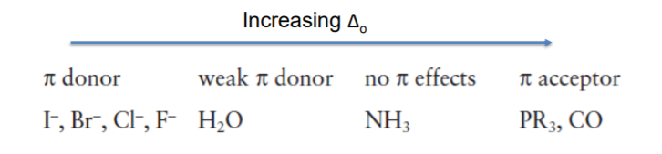
LFSE/CFSE (without PE)
Octahedral  $$Δ_{O}=\frac{4}{9}Δ_{t}$$ | $$Δ_{O}=-0.4*e^{t_{2g}}+0.6*e^{e_{g}}$$
Tetrahedral  - Fewer ligands  - no direct overlap  - most HS due to Δt < PE | $$Δ_{t}=0.4*e^{t_{2}}-0.6*e^{e}$$
Square planar complexes  $$Δ_{sp}=1.74Δ_{O}$$ | Mostly d⁸ and SFL
High spin vs low spin for d⁴ to d⁷
CFSE larger for LS complexes (maximum for low spin d⁶)
- explains stability of LS complexes and why octahedral coordination is preferred
- explains why HS complexes are more reactive

Jahn-Teller distortion (z-elongation)
Significantly | HS d⁴, LS d⁷ and d⁹
Weakly | d¹, d², LS d⁴, LS d⁵, HS d⁶ and HS d⁷
NB: T_{2g} in O_{h} and all d-orbitals in T_{h} do not point directly at ligands.

π-donor and π-acceptor effect
 | π-donor | π-acceptor
MO | 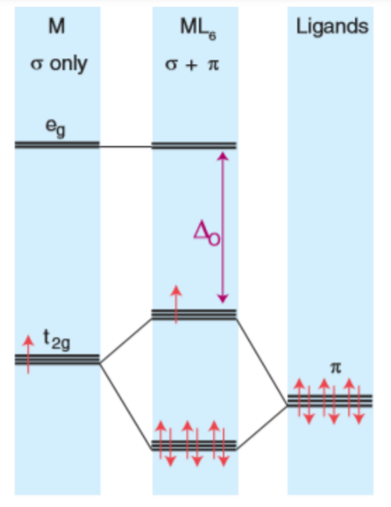 | 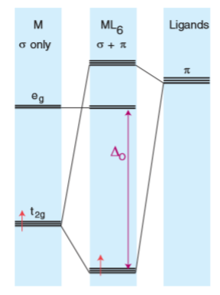
Description | Filled (bonding) π-orbitals  Typically π-bases  Decraeses Δ_{O}  With filled electrons in π symmetry orbitals ▪ π bases such as Cl- , Br- , OH- , O2- , H2O ▪ Lower in energy than partially filled d orbitals ▪ π orbitals of ligand and t2g of metal form bonding and antibonding MOs ▪ Electron from ligand π orbitals occupy bonding MOs ▪ Metal electron occupy | vacant (antibonding) π orbitals (LUMO)  Typically π-acids  Increases Δ_{O}  ▪ Bondig t2g MOs are largely of d character ▪ Lower in energy than previously t2g ▪ Large Δo ▪ π-acceptor ligands increase Δo
Examples | Cl⁻, Br⁻ , OH⁻ , O₂⁻ , H₂O | CO, PR₃ , N₂
SALC orbitals for metal complexes
Metal ion | s A_{1g}  p T_{1u}  d T_{2g} (no sigma) + E_{g}
Ligands | Varies a lot
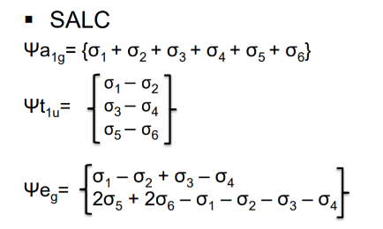

Metal complexes and π-effects
Octahedral – ML₆ | Tetrahedral – ML₄ | Square planar - ML₄
For π-effects:  See last page | Similar effect of π-donor  NB: e-orbital participates

CO as a ligand = π-acceptor
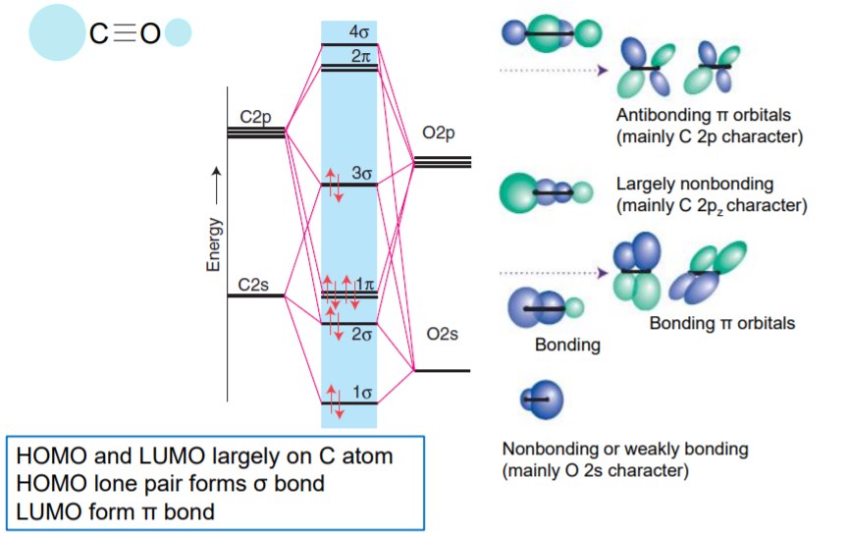
- SFL
- Poor sigma-donor
- Good pi-acceptor (pi from CO and t_{2g} of M has same symmetry)
- In UV-Vis we get d-d transitions at higher energy / lower wavelength
CO in metal complex (metal carbonyl)
- M donates electron density to pi* orbitals of CO via pi-backbonding
  - Bond order lowers (not pure triple bond any more)
  - The more backbonding, the lower frequency in FTIR

Microstates
are the different ways in which the electrons can occupy the orbitals specified.

$$↑$$ |  |  | $$↑$$
+1 | 0 | -1

$$↑↓$$
+1 | 0 | -1

(1⁺,1⁻) = (1⁺,-1⁺) = for 2p²

$$↑↓$$
+1 | 0 | -1

Calculate number of microstates
$$D_{t}(\#possible microstates)=\frac{\left(2N_{0}(\#degenrate orbitals in set/subshell)\right)!}{\left(2N_{0}-N_{e}\right)!N_{e}(\#e^{-}in configuration)!}$$
$$Exampels p^{2}: D_{t}=\frac{\left(2*3\right)!}{\left(2*3-2\right)!*2!}=15 D_{t}=\frac{\left(2*5\right)!}{\left(2*5-2\right)!*2!}=45$$
$Short cut: \#Microstates=(2L+1)(2S+1)$

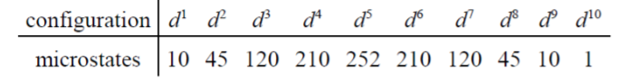

Terms
=groups of microstates of same energy when electron-electron repulsion are taken into account.
Russel-Saunders coupling: ${}_{ }^{2S+1}L$ where S=possible values of m_{s} and L=possible values of m_{l}.
(PS: L-S coupling is for lighter atoms, and J-J coupling for heavier atoms i.e., Z>30).
Term energies determined by:
- Highest multiplicity gives lowest energy
- Highest permitted value of L gives lowest energy
All possible atomic terms | The ground term
$$L=l_{1}+l_{2}, { l}_{1}+l_{2}-1, …, |l_{1}-l_{2}|$$  $$S=s_{1}+s_{2}, { s}_{1}+s_{2}-1, …, |s_{1}-s_{2}|$$  How to find the atomic terms?  - Combine all values of L and S | The atomic term of lowest energy.  The direct method for finding ground term?  - Find microstate of highest value of S/M_{S}  - Find the highest permitted value of L/M_{L} for that multiplicity

Overview of terms for different configurations
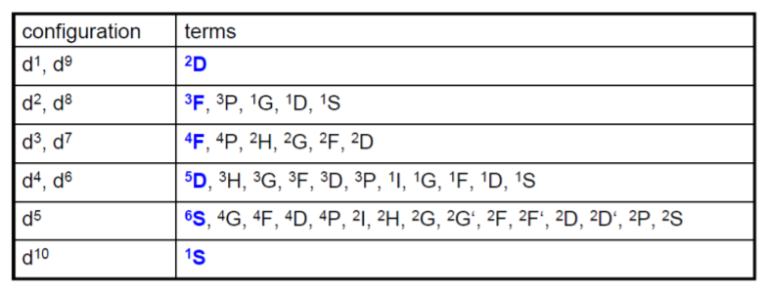

Complex terms
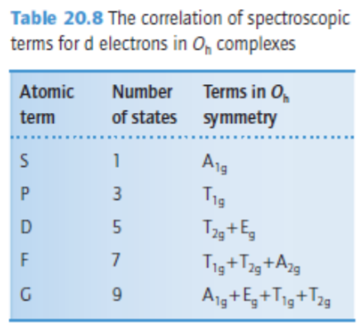

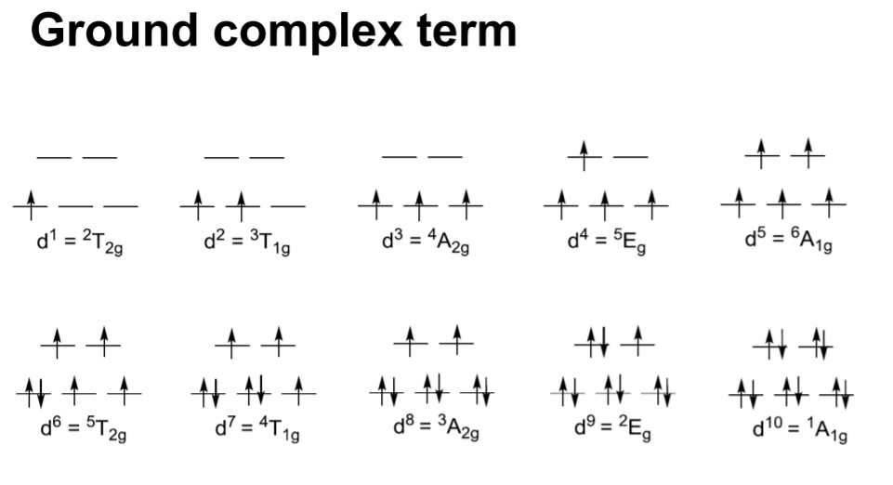
Orgel diagrams
- For discussion of simple electronic spectra
- Only spin allowed transitions
- Oversimplified and qualitative (doesn’t show all possible terms and transitions)
- Mostly for high spin complexes
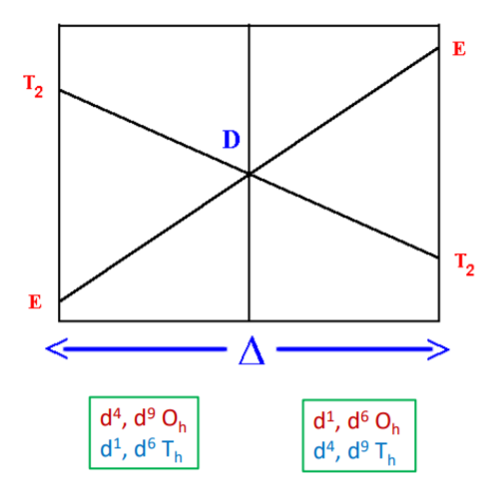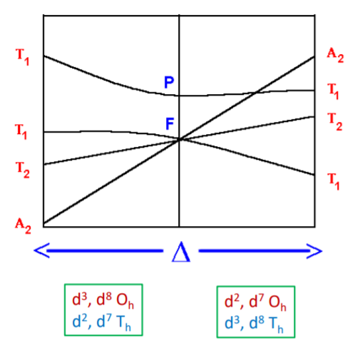

Tanabe-Sugano diagram
- To predict the UV-Vis spectra
- Shows the correlation of all terms
  - Energies expressed as E/B
  - E/B plotted against Δo /B
  - B is Racah parameter
  - Energy of ground term is set to zero ▪ Energies of other terms are plotted with respect to ground term
- Abrupt change in slope change in the identity of ground term
- High spin to low spin by increasing ligand field strength
- Non-crossing rule: Two terms of same symmetry type approaching each other by increasing ligand field will not cross but bend apart from each other

PS: Til eksamen – Sammenlign orgel med tanabe-sugano!

d² configuration | d³ configuration
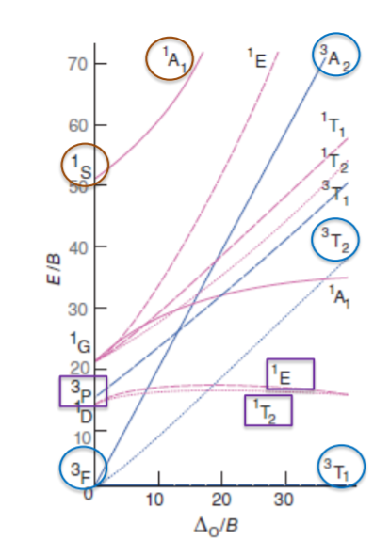

Regn ut B (Racah) fra kombo av UV-VIS og tilhørende Tanabe-Sugano diagram:
- $Energidiff. fra UV-VIS spectrum: \frac{top1 cm^{-1}}{top2 cm^{-1}}=TALL=\frac{Δ_{O}}{B}$
- $Les av T-S der \frac{Δ_{O}}{B}=TALL , finn TALL2$
- $TALL2*B= top1 cm^{-1} \left(fra UV-VISspekter\right)$
- $B= \frac{top1 cm^{-1} }{TALL2}$
- $\frac{Δ_{O}}{B}=TALL → Δ_{O}=TALL*B$

Width of absorption bands
- Some changes with $Δ_{o}$ (if $Δ_{o}$ then even broader)
- Spin forbidden = sharp but weak

Selection rules
- Spin selection rule
Electronic transitions with change in spin multiplicity are forbidden.
Same spin = allowed.
- The Laporte selection rule
All transitions in a centrosymmetric must be accompanied by a change in parity.
Allowed: $g⟷u, s⟷p, p⟷d, d⟷f$
Forbidden: $g⟷g,u⟷u, s⟷s, p⟷p, d⟷d, s⟷d, p⟷f$
i.e. all d-d-transitions in O_{h} complexes are forbidden

Different types of transitions
- Charge transfer
  - LMCT or MLCT
  - Excitation of electrons from MO of predominately M or predominately L character
  - very high intensity (spin allowed, Laporte allowed)
- d-d transitions
  - Laporte forbidden (in O_{h} complex)
  - Spin…
    - … allowed: excitation of electrons from t_{2g} to e_{g}, intermediate intensity
    - … forbidden: Very weak intensity due to both spin and Laporte forbidden. Can be seen due to LS coupling.

More on UV-VIS and spectroscopy
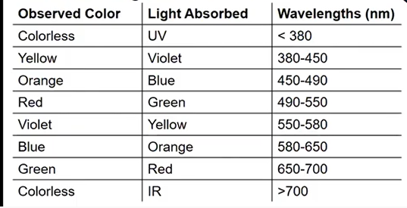

Fluorescence and phosphorescence
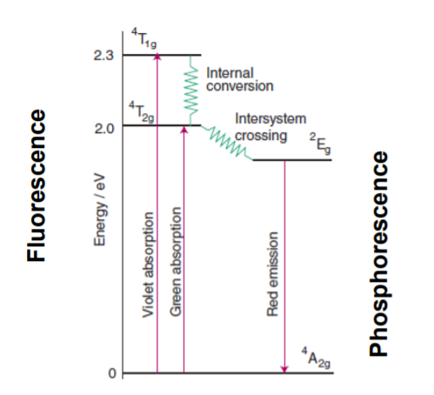
Techniques to determine oxidation state:
- UV-Vis: Yes
  - Cu⁺ is d¹⁰ – no dd transition & Cu²⁺ is d⁹ – dd transitions
  - Needs references
- XPS: Yes
  - Kinetic E of core electrons measured, Bond E of electrons calculated
  - Bond E depends on effective nuclear charge (which depends on oxidation state)
- XAS: Yes
  - E0 is measured in the XANES region
  - Same principle as XPS
  - Needs references, Average technique

Techniques to determine geometry (octahedral/tetrahedral)
- XPS: No (ikke info om naboer)
- UV-Vis: Yes. Oh complex larger splitting than Th Higher energy / lower wavelength for Oh complex in UV Vis Needs references Due to Laporte: Th will be more intense than Oh
- XAS: Yes XANES Pre-edge (1s to 3d): Due to Laporte, higher intensity for Th EXAFS: Number of neighbors, average technique Needs references
True/false:
- 6-koordinerte ML-komplekser er mer stabile fordi de oppfyller 18-elektronregelen.
- Topper for d-d-overganger har lavere energi for tetraedriske enn oktaedriske.
- Absorbansen i et UV-vis-spekter avhenger av Beer-Lamberts lov (A = ε*c*l)
  - type overgang, konsentrasjon og lengde av lysvei
- XPS er overflatesensitiv (kort mean free path of e⁻), XAS er ikke det.
- Overgangen 1s 3d vil si noe om geometrien (Laporte, ses i pre-edge XAS).
  - Sentrosymmetrisk lav
- XPS kan skille mellom ulike oksidasjonstilstander. Bindingsenergi fra Koopmans ligning:
  - Ulike topper for ulik kjerneladning og ergo ulike oksidasjonstilstander
- UPS gir informasjon om energien til molekylorbitaler og i hvilken grad molekylorbitalene er viktige for strukturen på molekylet
  - Vi finner bindingsenergien til MO’ene via Koopman’s likning og dersom vi får finstruktur i spekteret har MO stor betydning for strukturen.

Jahn Teller vil gi multiple topper og ytterligere energifordeling av d-orbitalene. I utgangspunktet kan man skille mellom geometri for forbindelser som det kjøres UVvis på, men det krever veldig mange forskjellige referanseprøver dersom vi innehar forskjellige metall/ligand-komplekser da enhver absorpsjonstopp ikke nødvendigvis tilsvarer én geometri. Vi har derfor måttet sammenlikne med kjente miljøer og kjente komplekser for å kunne si noe om forskjellig geometri så det er ikke sikkert prosessen hadde vært så lett totalt sett.

